**Tutorial for the overly complicated process I use to segment nuclei in static images**

* Open image in Fiji/ImageJ.
  + If multi-channel, set image to channel of interest (usually blue) and go to

Image>Hyperstack>Reduce Dimensionality…

* Run Plugins > Integral Image Filters > Normalize Local Contrast (you may have to install it, it is available online!
  + I usually use 50 as the radius for x and y directions, with a check on the “center” option.
* Save that image (henceforth “contrast”) and the original single-channel image as 8-bit (Type…>8-bit and then Save as…)(henceforth “8-bit”).
* Now onto Icy; open contrast image
* Run HK means (on the Detection & Tracking tab, top of the window). You may play with the settings to improve this initial segmentation mask
* Search for protocol [“Remove ROIs touching image border”](http://icy.bioimageanalysis.org/protocol/remove-rois-touching-image-border/)
  + Select name of image and then click “Run”

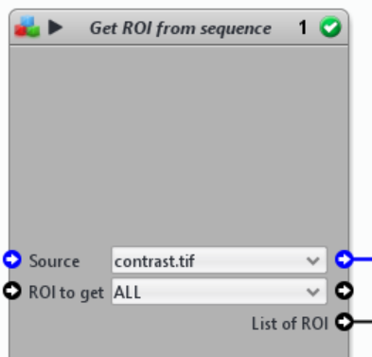

* Remove rois that are not proper (e.g. those who are on the background and not on nuclei)

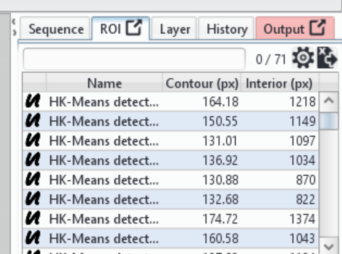

* Then, select Active Contours (on the Detection & Tracking tab, top of the window).
  + These are the only options you need to select, but feel free to play with the variables!

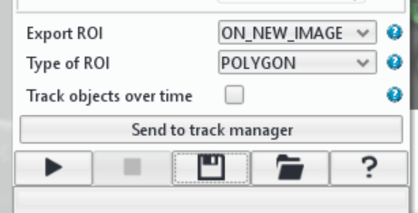

* Run plugin, wait for it to end. A new image will show up with the final ROIS. Save that (Tab Image/Sequence>Save as…
* Tab ImageJ>Detached Mode
* Tab ImageJ>Convert to IJ
  + Two new windows should show up: the contrast image and a window called “ROI Manager. On ROI Manager, click “More”, “Save…”, and save the file (automatically called RoiSet)

***IF YOU ONLY WANT SEGMENTED IMAGES - DO THE STEPS BELOW;  
otherwise the notebook for the dynamic analysis takes care of the final segmentation steps***

* Back to ImageJ – drag the RoiSet file to open it on ImageJ. It will open the ROIManager
* Drag the file RoiCut.ijm to ImageJ (I’ll attach to email)
  + It will open a window like this:

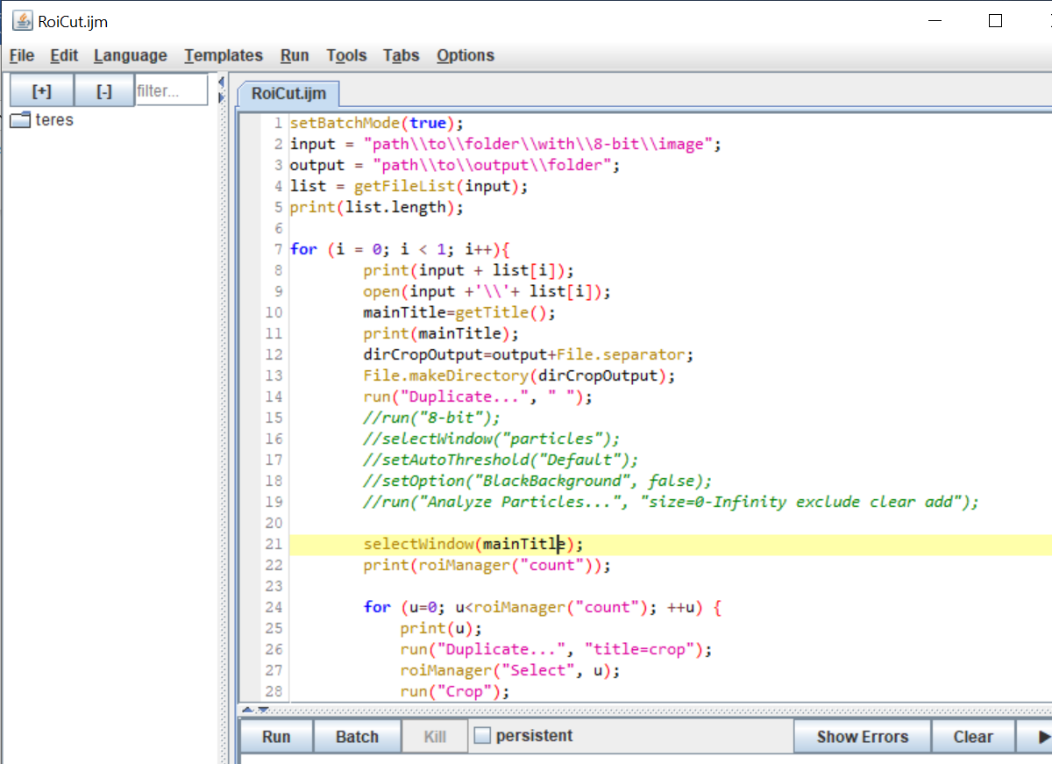

* + The input path should be a folder with only the 8-bit image; the output path can be the same as the input
  + Press “run”

That’s it! You should have individual images with segmented nuclei in the output path folder.